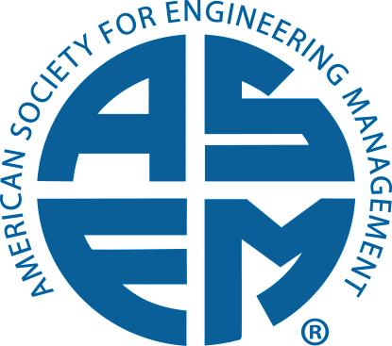
U.S. Regional Directors and International Director Responsibilities

- Participate in meetings of the Board of Directors (BOD)
  - Two major meetings of the BOD each year
    - Spring – future conference site or other location
    - Fall – International Annual Conference
  - Monthly BOD conference calls

- Work with the regional and International Directors’ group on relevant initiatives related to growing membership
  - Publishing a quarterly regional newsletter for all members, university program offering engineering management degrees, and technology-focused organizations in the assigned region. Contents include ASEM activities, honors for programs and individual members, and special events.
  - Contacting and engaging schools (email or phone – no travel expected) with engineering management programs to encourage participation in ASEM activities including
    - Joining ASEM (faculty as regular members and departments as corporate members)
    - Submitting papers and attending the International Annual Conference
    - Forming an ASEM student chapter (Goal: one new student chapter per year)
    - Sending a student team to the case study competition at the International Annual Conference, etc.
  - Contacting and engaging technology-based companies (email or phone – no travel expected) to encourage participation in ASEM activities including
    - Joining ASEM (engineers and technical managers as regular members and the companies as corporate members)
    - Submitting papers and attending the International Annual Conference
    - Encouraging the formation of ASEM professional local sections (Goal: one new local section per year)
  - Develop and maintain information and statistics on membership and participation in ASEM activities by members and organizations in the assigned region including
    - Student chapters and local sections
    - Individual and corporate members
    - Attendance at the international annual conference
    - Purchases of ASEM products
    - Certified MS programs
    - Certified engineering managers

- Promote the Society in the assigned region
  - Serve as the primary point of contact for information, inquiries, and support in the region
  - Engage individuals through ASEM social media sites in discussions of pertinent engineering management topics (ASEM LinkedIn and Facebook sites already established)
  - Market ASEM corporate training programs to engineering companies
  - Market the Engineering Manager Certification (EMPC) program to individuals and companies in the region
  - Promote the ASEM MS certification program to universities in the region
  - Promote the ASEM publications available for purchase
  - Provide appropriate help during annual conference if it falls in the assigned region in terms of publicity, funding, speakers, etc.
  - Participate in regional or national conferences of other professional societies that complement ASEM

